**Spring REST using Spring Boot 3**

**1.spring-rest-handson  
  
Hands on 1**

**Create a Spring Web Project using Maven**

1. Go to <https://start.spring.io/>
2. Change Group as “com.cognizant”
3. Change Artifact Id as “spring-learn”
4. Select Spring Boot DevTools and Spring Web
5. Create and download the project as zip  
     
   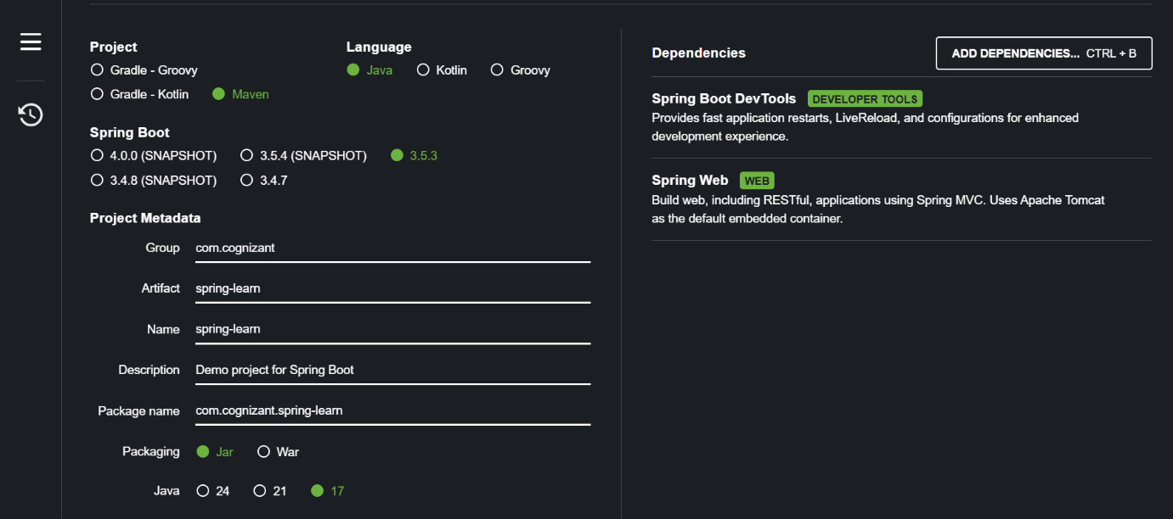
6. Extract the zip in root folder to Eclipse Workspace
7. 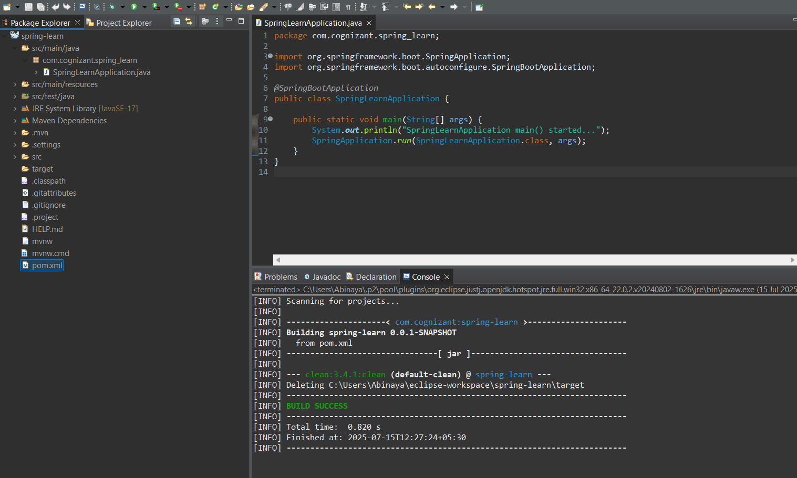Build the project using ‘mvn clean package -Dhttp.proxyHost=proxy.cognizant.com -Dhttp.proxyPort=6050 -Dhttps.proxyHost=proxy.cognizant.com -Dhttps.proxyPort=6050 -Dhttp.proxyUser=123456’ command in command line.
8. Import the project in Eclipse

SpringLearnApplication.java

package com.cognizant.springlearn;

import org.springframework.boot.SpringApplication;

import org.springframework.boot.autoconfigure.SpringBootApplication;

@SpringBootApplication

public class SpringLearnApplication {

public static void main(String[] args) {

System.out.println("SpringLearnApplication main() started...");

SpringApplication.run(SpringLearnApplication.class, args);

}

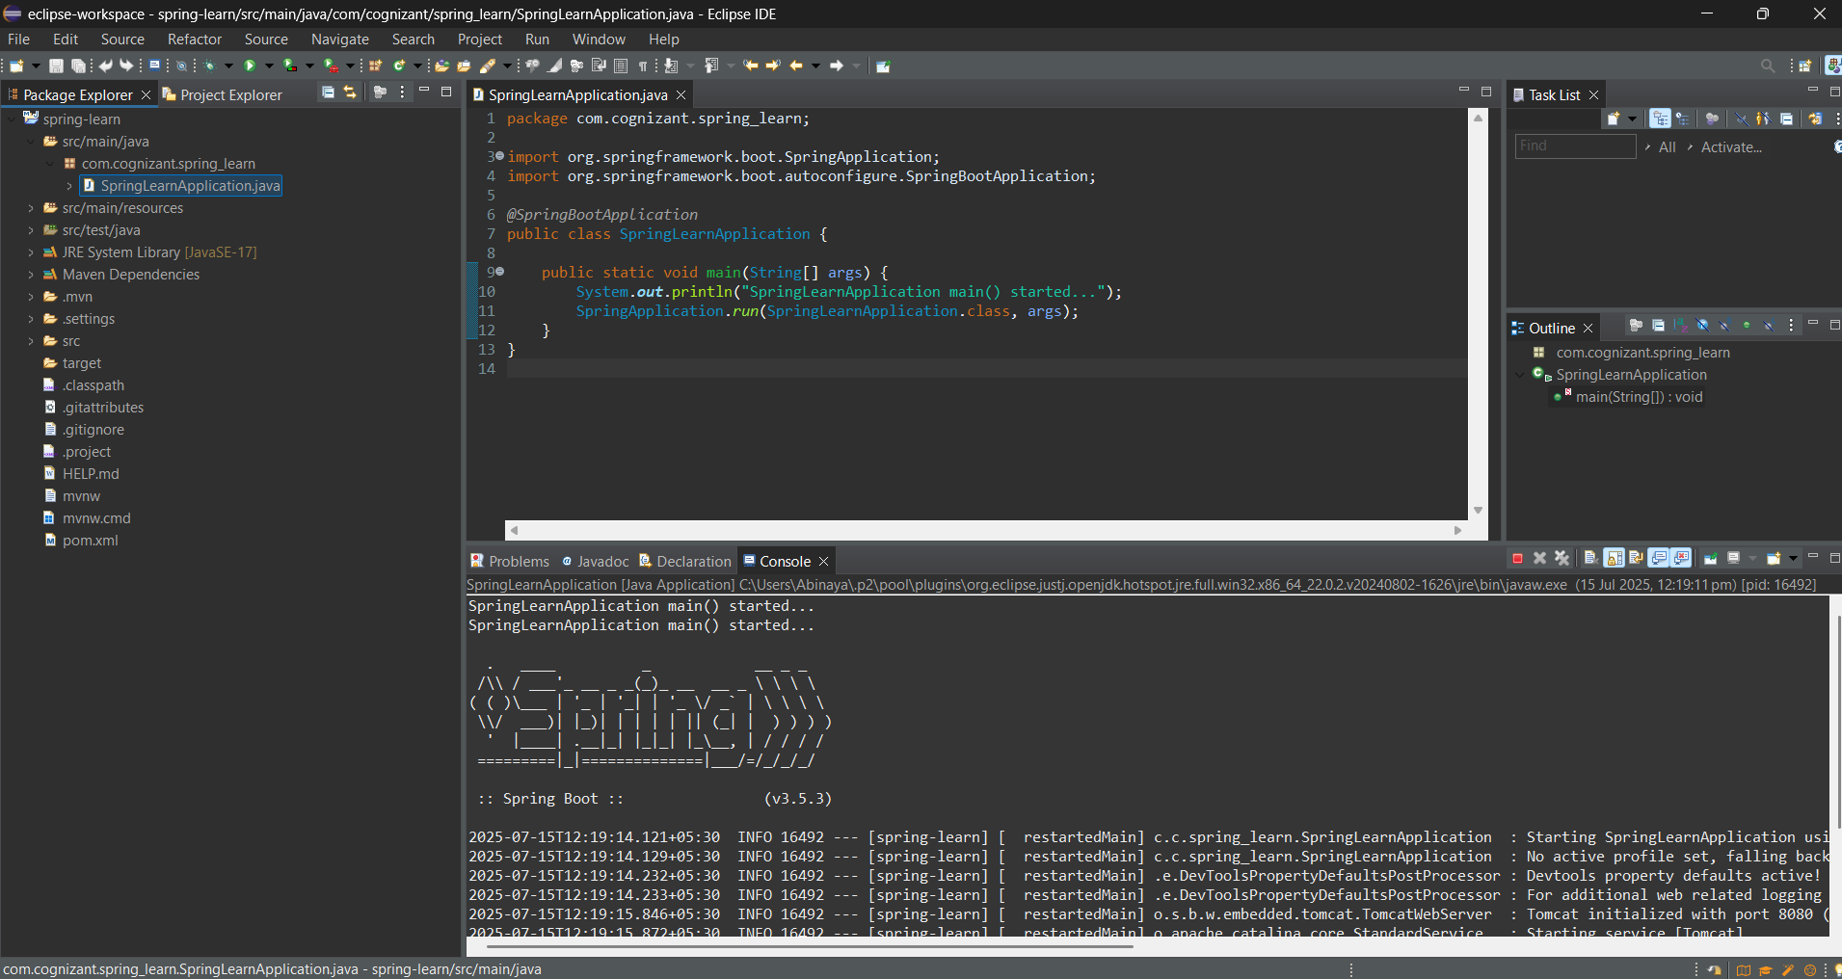}  
  
**Output:**

**HandsOn- 4**

**Spring Core – Load Country from Spring Configuration XML**

**1.SpringLearnApplication.java**

package com.cognizant.spring_learn;

import com.cognizant.spring_learn.Country;

import org.slf4j.Logger;

import org.slf4j.LoggerFactory;

import org.springframework.boot.autoconfigure.SpringBootApplication;

import org.springframework.context.ApplicationContext;

import org.springframework.context.support.ClassPathXmlApplicationContext;

@SpringBootApplication

public class SpringLearnApplication {

private static final Logger *LOGGER* = LoggerFactory.*getLogger*(SpringLearnApplication.class);

public static void main(String[] args) {

*LOGGER*.info("STARTING: SpringLearnApplication");

*displayCountry*();

*LOGGER*.info("STOPPING: SpringLearnApplication");

}

public static void displayCountry() {

*LOGGER*.info("START");

ApplicationContext context = new ClassPathXmlApplicationContext("country.xml");

Country country = (Country) context.getBean("country", Country.class);

*LOGGER*.debug("Country : {}", country.toString());

((ClassPathXmlApplicationContext) context).close();

*LOGGER*.info("END");

}

}  
  
**2.Country.java**

package com.cognizant.spring_learn;

import org.slf4j.Logger;

import org.slf4j.LoggerFactory;

public class Country {

private static final Logger LOGGER = LoggerFactory.getLogger(Country.class);

private String code;

private String name;

public Country() {

LOGGER.debug("Inside Country Constructor.");

}

public String getCode() {

LOGGER.debug("Getting code: {}", code);

return code;

}

public void setCode(String code) {

LOGGER.debug("Setting code: {}", code);

this.code = code;

}

public String getName() {

LOGGER.debug("Getting name: {}", name);

return name;

}

public void setName(String name) {

LOGGER.debug("Setting name: {}", name);

this.name = name;

}

@Override

public String toString() {

return "Country [code=" + code + ", name=" + name + "]";

}

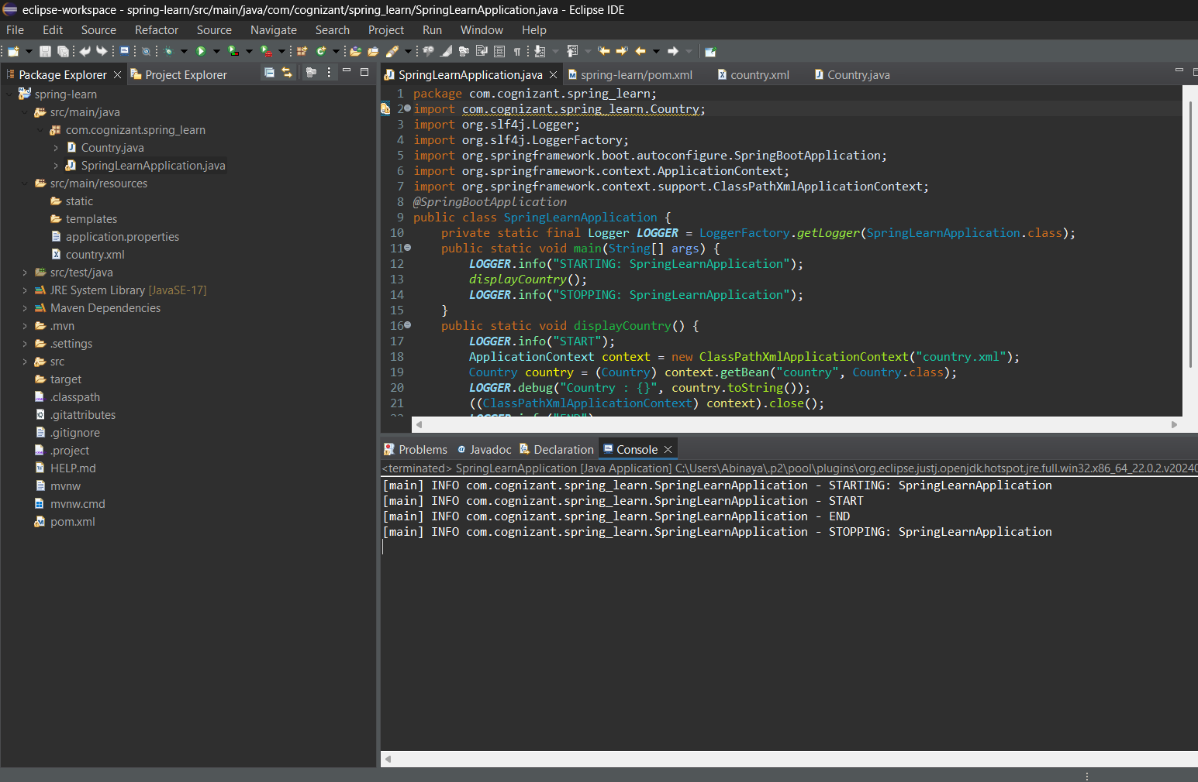}  
  
**Output:**

**2.spring-rest-handson**

**Hands On-1**

**Hello World RESTful Web Service** 

**SpringLearnApplication.java**

package com.cognizant.spring_learn;

import org.springframework.boot.SpringApplication;

import org.springframework.boot.autoconfigure.SpringBootApplication;

@SpringBootApplication

public class SpringLearnApplication {

public static void main(String[] args) {

SpringApplication.run(SpringLearnApplication.class, args);

}

}  
  
HelloController.java   
  
package com.cognizant.spring_learn.controller;

import org.slf4j.Logger;

import org.slf4j.LoggerFactory;

import org.springframework.web.bind.annotation.GetMapping;

import org.springframework.web.bind.annotation.RestController;

@RestController

public class HelloController {

private static final Logger LOGGER = LoggerFactory.getLogger(HelloController.class);

@GetMapping("/hello")

public String sayHello() {

LOGGER.info("START - /hello endpoint hit");

String response = "Hello World!!";

LOGGER.info("END - /hello returning: {}", response);

return response;

}

}

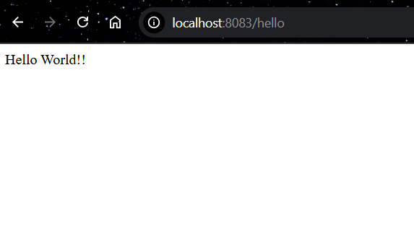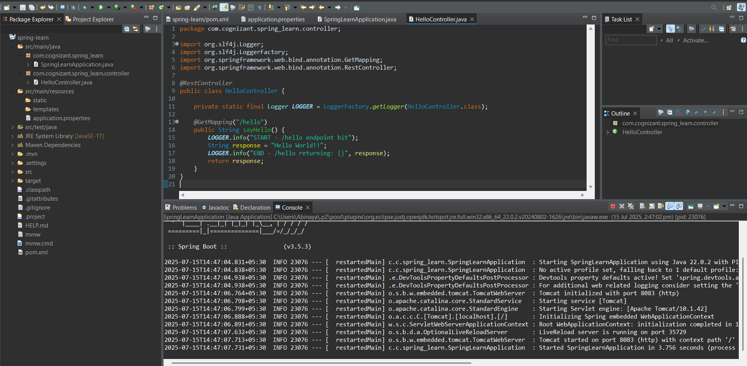  
**Output:**

**Hands On - 2**

**REST - Country Web Service**  
Write a REST service that returns India country details in the earlier created spring learn application.  
  
URL: /country  
Controller: com.cognizant.spring-learn.controller.CountryController  
Method Annotation: @RequestMapping  
Method Name: getCountryIndia()  
Method Implementation: Load India bean from spring xml configuration and return  
Sample Request: <http://localhost:8083/country>  
  
  
**Country.xml**

<?xml version="1.0" encoding="UTF-8"?>

<beans xmlns="http://www.springframework.org/schema/beans"

xmlns:xsi="http://www.w3.org/2001/XMLSchema-instance"

xsi:schemaLocation="http://www.springframework.org/schema/beans

https://www.springframework.org/schema/beans/spring-beans.xsd">

<bean id="country" class="com.cognizant.spring_learn.Country">

<property name="code" value="IN"/>

<property name="name" value="India"/>

</bean>

</beans>

**Country.java**

package com.cognizant.spring_learn;

import org.slf4j.Logger;

import org.slf4j.LoggerFactory;

public class Country {

private static final Logger LOGGER = LoggerFactory.getLogger(Country.class);

private String code;

private String name;

public Country() {

LOGGER.debug("Inside Country Constructor");

}

public String getCode() {

LOGGER.debug("Getting code");

return code;

}

public void setCode(String code) {

LOGGER.debug("Setting code: {}", code);

this.code = code;

}

public String getName() {

LOGGER.debug("Getting name");

return name;

}

public void setName(String name) {

LOGGER.debug("Setting name: {}", name);

this.name = name;

}

@Override

public String toString() {

return "Country [code=" + code + ", name=" + name + "]";

}

}

**Country Controller .java**

package com.cognizant.spring_learn.controller;

import com.cognizant.spring_learn.Country;

import org.slf4j.Logger;

import org.slf4j.LoggerFactory;

import org.springframework.context.ApplicationContext;

import org.springframework.context.support.ClassPathXmlApplicationContext;

import org.springframework.web.bind.annotation.RequestMapping;

import org.springframework.web.bind.annotation.RestController;

*@RestController*

public class CountryController {

private static final Logger ***LOGGER*** = LoggerFactory.*getLogger*(CountryController.class);

*@RequestMapping*("/country")

public Country getCountryIndia() {

***LOGGER***.info("START - getCountryIndia()");

ApplicationContext context = new ClassPathXmlApplicationContext("country.xml");

Country country = context.getBean("country", Country.class);

***LOGGER***.debug("Country: {}", country);

***LOGGER***.info("END - getCountryIndia()");

return country;

}

}

**SpringLearnApplication.java**

package com.cognizant.spring_learn;

import org.slf4j.Logger;

import org.slf4j.LoggerFactory;

import org.springframework.boot.SpringApplication;

import org.springframework.boot.autoconfigure.SpringBootApplication;

*@SpringBootApplication*

public class SpringLearnApplication {

private static final Logger ***LOGGER*** = LoggerFactory.*getLogger*(SpringLearnApplication.class);

public static void main(String[] args) {

***LOGGER***.info("START - SpringLearnApplication");

// Start Spring Boot application

SpringApplication.*run*(SpringLearnApplication.class, args);

***LOGGER***.info("END - SpringLearnApplication");

}

}

**Output:**

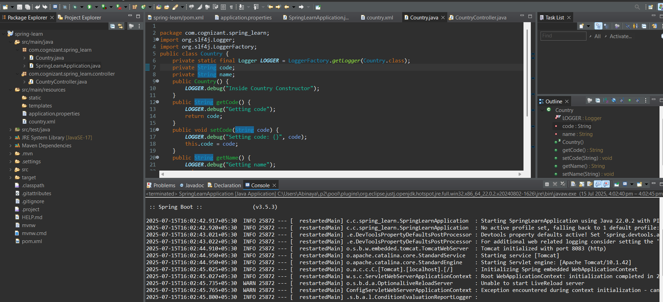

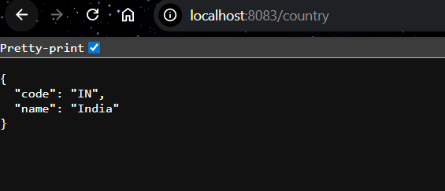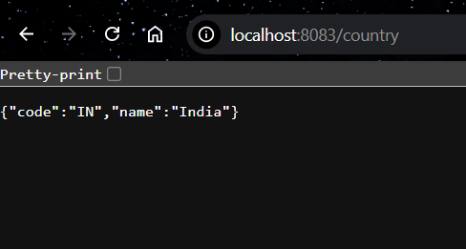

**REST - Get country based on country code**   
  
**Write a REST service that returns a specific country based on country code. The country code should be case-insensitive.**  
Controller: com.cognizant.spring-learn.controller.CountryController  
Method Annotation: @GetMapping("/countries/{code}")  
Method Name: getCountry(String code)  
Method Implemetation: Invoke countryService.getCountry(code)   
Service Method: com.cognizant.spring-learn.service.CountryService.getCountry(String code)

Sample Request: <http://localhost:8083/country/in>

**Country .java**

package com.cognizant.spring_learn;

public class Country {

private String code;

private String name;

public Country() {

System.out.println("Inside Country Constructor.");

}

public String getCode() {

System.out.println("Inside getCode");

return code;

}

public void setCode(String code) {

System.out.println("Inside setCode");

this.code = code;

}

public String getName() {

System.out.println("Inside getName");

return name;

}

public void setName(String name) {

System.out.println("Inside setName");

this.name = name;

}

@Override

public String toString() {

return "Country [code=" + code + ", name=" + name + "]";

}

}

**Country.xml**

<?**xml** version=*"1.0"* encoding=*"UTF-8"*?>

<**beans** xmlns=*"http://www.springframework.org/schema/beans"*

xmlns:xsi=*"http://www.w3.org/2001/XMLSchema-instance"*

xsi:schemaLocation=*"http://www.springframework.org/schema/beans*

*https://www.springframework.org/schema/beans/spring-beans.xsd"*>

<**bean** id=*"countryList"* class=*"java.util.ArrayList"*>

<**constructor-arg**>

<**list**>

<**bean** class=*"com.cognizant.spring_learn.Country"*>

<**property** name=*"code"* value=*"IN"* />

<**property** name=*"name"* value=*"India"* />

</**bean**>

<**bean** class=*"com.cognizant.spring_learn.Country"*>

<**property** name=*"code"* value=*"US"* />

<**property** name=*"name"* value=*"United States"* />

</**bean**>

<**bean** class=*"com.cognizant.spring_learn.Country"*>

<**property** name=*"code"* value=*"DE"* />

<**property** name=*"name"* value=*"Germany"* />

</**bean**>

<**bean** class=*"com.cognizant.spring_learn.Country"*>

<**property** name=*"code"* value=*"JP"* />

<**property** name=*"name"* value=*"Japan"* />

</**bean**>

</**list**>

</**constructor-arg**>

</**bean**>

</**beans**>

**CountryService.java**

package com.cognizant.spring_learn.services;

import com.cognizant.spring_learn.Country;

import org.springframework.context.ApplicationContext;

import org.springframework.context.support.ClassPathXmlApplicationContext;

import org.springframework.stereotype.Service;

import java.util.List;

@Service

public class CountryService {

public Country getCountry(String code) {

ApplicationContext context = new ClassPathXmlApplicationContext("country.xml");

List<Country> countries = (List<Country>) context.getBean("countryList");

// Case-insensitive match using lambda

return countries.stream()

.filter(country -> country.getCode().equalsIgnoreCase(code))

.findFirst()

.orElse(null);

}

}

**CountryController .java**

package com.cognizant.spring_learn.controller;

import com.cognizant.spring_learn.Country;

import com.cognizant.spring_learn.services.CountryService;

import org.slf4j.Logger;

import org.slf4j.LoggerFactory;

import org.springframework.beans.factory.annotation.Autowired;

import org.springframework.web.bind.annotation.*;

*@RestController*

public class CountryController {

private static final Logger ***LOGGER*** = LoggerFactory.*getLogger*(CountryController.class);

*@Autowired*

private CountryService countryService;

*@GetMapping*("/countries/{code}")

public Country getCountry(*@PathVariable* String code) {

***LOGGER***.info("START - getCountry()");

Country country = countryService.getCountry(code);

***LOGGER***.info("END - getCountry()");

return country;

}

}

**SpringLearnApplication.java**

package com.cognizant.spring_learn;

import org.slf4j.Logger;

import org.slf4j.LoggerFactory;

import org.springframework.boot.SpringApplication;

import org.springframework.boot.autoconfigure.SpringBootApplication;

*@SpringBootApplication*

public class SpringLearnApplication {

private static final Logger ***LOGGER*** = LoggerFactory.*getLogger*(SpringLearnApplication.class);

public static void main(String[] args) {

***LOGGER***.info("START - SpringLearnApplication");

// Start Spring Boot application

SpringApplication.*run*(SpringLearnApplication.class, args);

***LOGGER***.info("END - SpringLearnApplication");

}

}

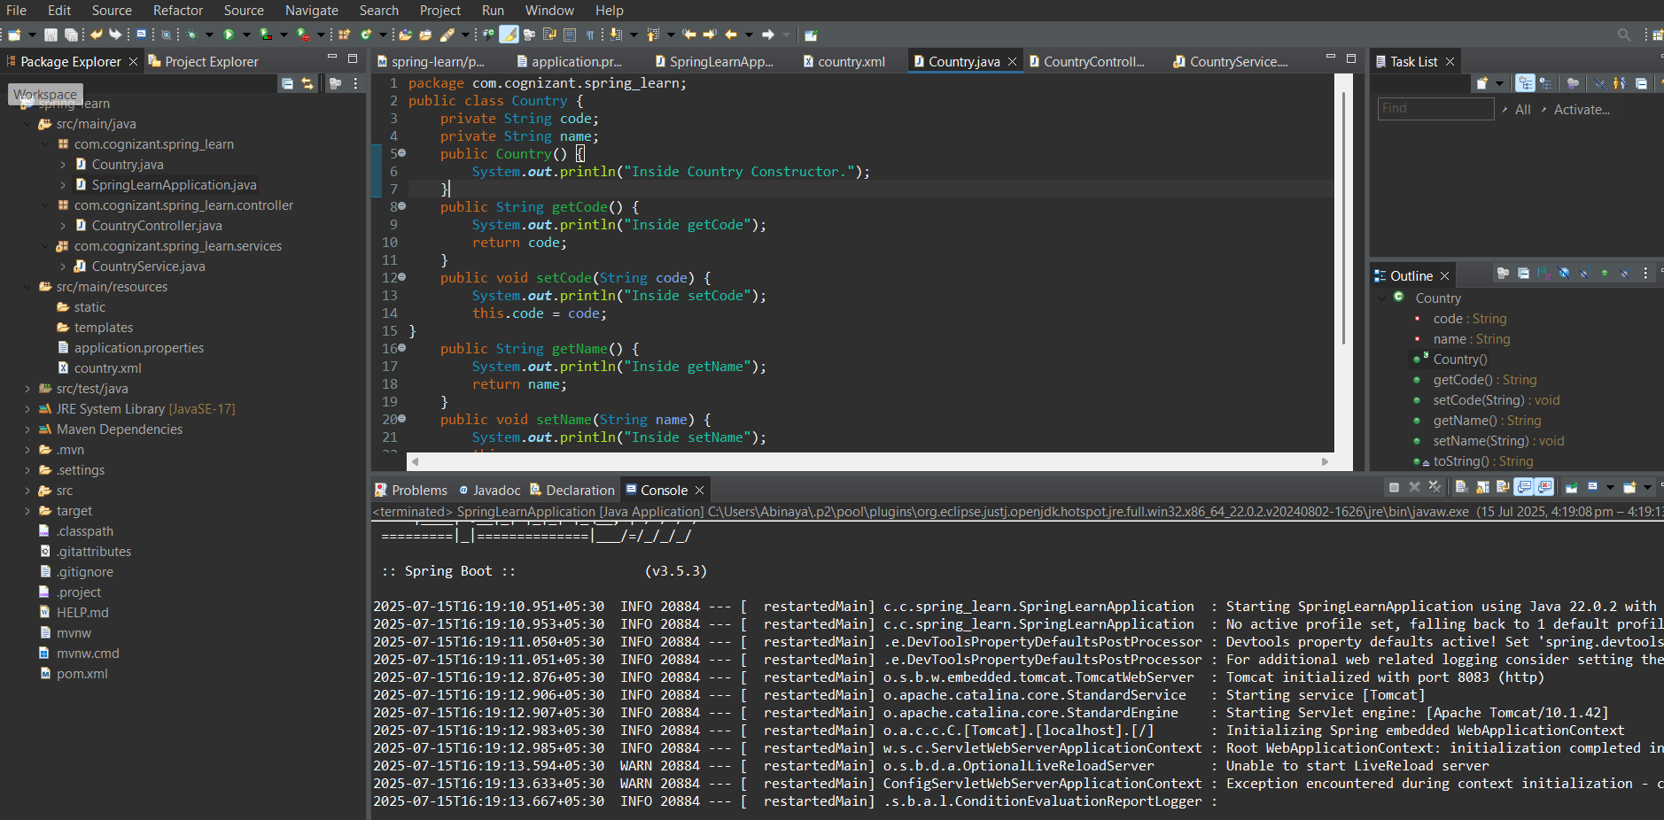**Output:**

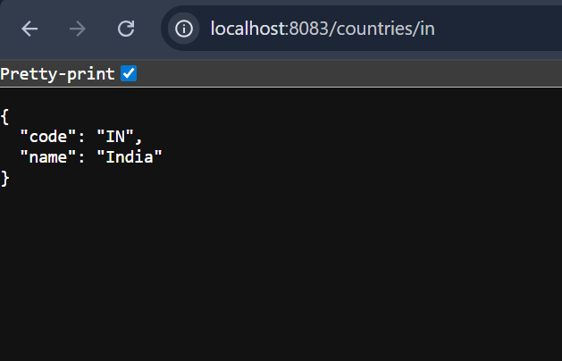

**5. JWT HandsOn**

**Create an authentication service that returns JWT**

**UserRequest.java**

package com.cognizant.jwt_auth_service.model;

import jakarta.validation.constraints.NotBlank;

import jakarta.validation.constraints.Size;

public class UserRequest {

*@NotBlank*(message = "Username is required")

*@Size*(min = 3, max = 20, message = "Username must be 3 to 20 characters")

private String username;

*@NotBlank*(message = "Password is required")

*@Size*(min = 5, message = "Password must be at least 5 characters")

private String password;

// Getters and Setters

public String getUsername() {

return username;

}

public void setUsername(String username) {

this.username = username;

}

public String getPassword() {

return password;

}

public void setPassword(String password) {

this.password = password;

}

}

**AuthController.java**

package com.cognizant.jwt_auth_service.controller;

import com.cognizant.jwt_auth_service.model.UserRequest;

import org.slf4j.Logger;

import org.slf4j.LoggerFactory;

import org.springframework.http.ResponseEntity;

import org.springframework.validation.annotation.Validated;

import org.springframework.web.bind.annotation.*;

import jakarta.validation.Valid;

*@RestController*

*@RequestMapping*("/api")

*@Validated*

public class AuthController {

private static final Logger ***LOGGER*** = LoggerFactory.*getLogger*(AuthController.class);

*@PostMapping*("/validate")

public ResponseEntity<String> validateUser(*@Valid* *@RequestBody* UserRequest userRequest) {

***LOGGER***.info("Received validation request for user: {}", userRequest.getUsername());

return ResponseEntity.*ok*("Valid input!");

}

}

**JwtAuthServiceApplication.java**

package com.cognizant.jwt_auth_service;

import org.springframework.boot.SpringApplication;

import org.springframework.boot.autoconfigure.SpringBootApplication;

@SpringBootApplication

public class JwtAuthServiceApplication {

public static void main(String[] args) {

SpringApplication.run(JwtAuthServiceApplication.class, args);

}

}

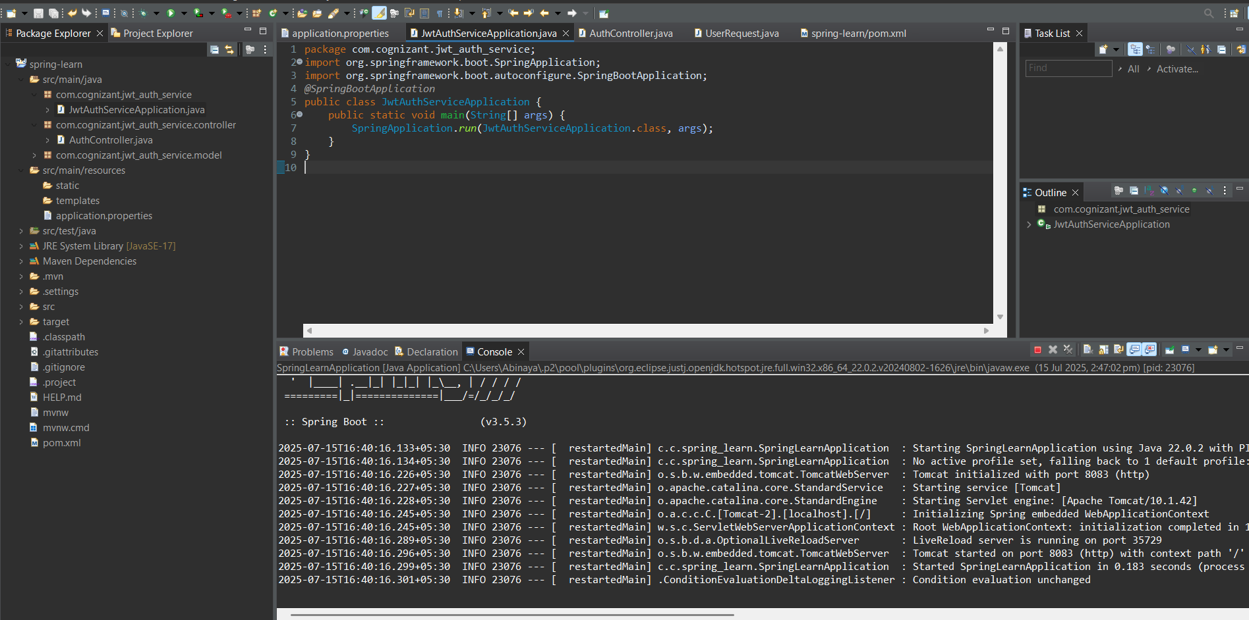**Output:**